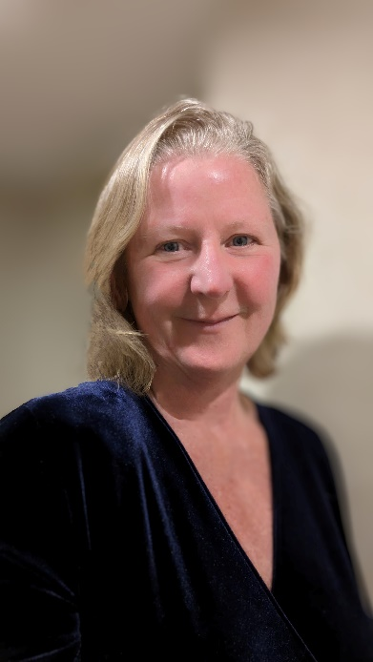
Diane Northey is a highly skilled and experienced professional with a diverse background in business development, engineering, and design. With over 26 years of experience in manufacturing field, Diane has proven herself to be a valuable asset, to any organization she works for.
She began her career at Fishercast Global, where she spent 15 years gaining extensive hands-on experience, in the injection metal process. She was cross trained in various roles, including quality inspection, calibration, and machine operation. Diane was responsible for the entire production process, from raw materials to end product. She also gained proficiency in software programs such as ProE, AutoCAD, and Microsoft Office.
Currently, she serves as the Business Development Coordinator and Quality Manager at Belair Mechatronics Inc., where she has successfully implemented and is maintaining an ISO9001 quality management system and ISO14001 Environmental management system. in accordance with the ISO standards. She is responsible for coordinating the people, as well as working with government and other contributors to develop research and development grant proposals.
Prior to her current role, Diane worked at Goodwin Metals Inc. as a Business Development Coordinator, where she grew customer and sales through various marketing techniques. She also handled accounting duties such as payroll, inventory control, and accounts receivable and payable.
Before that, Diane was the Supervisor of Engineering Research and Design at a medical devices company. During her time there, she supervised Engineering, Research and Design of new products. She was responsible maintaining ISO13485 in her department for prototype development and testing, CAD design, equipment & facility maintenance, and staff training. She also managed the facility maintenance and clean room environmental control.
Diane has also worked for LMG Drafting and Design Ltd as an Architectural Designer, and at Klassen Engineering Ltd., updating electrical drawings using AutoCAD, as well as assisting the engineer on specific projects. She also liaised with customer design and operations personnel to gather site-specific design information.
In addition to her professional work, Diane is an active volunteer within the engineering community. She has been a member and volunteer of the Ontario Association of Certified Engineering Technicians and Technologists (OACETT) since 1998 and has served on various boards and committees. She has held positions such as Vice President of Professional Affairs and Service, Eastern Regional Councillor, Eastern Regional Secretary Treasurer, Peterborough Chapter Chair, Chapter Vice Chair, and Secretary Treasurer. Diane has also chaired committees such as Finance, Women in Technology, and Provincial Awards.
Outside of OACETT, Diane has dedicated her time to various other volunteer activities with IEEE, PEO, and Fleming college. She has served as Chair and Executive Member of the Peterborough Engineering Challenge for 13 years, Chair of the Peterborough Engineering Symposium for 10 years, and a judge at the Peterborough Regional Science Fair. She has also served on committees and acted as a judge at Fleming College, including the Automation Committee, Computer Engineering Committee, and Technology Showcase Judging. Additionally, Diane has been involved with the Women in STEM Committee in Peterborough.
Diane is truly dedication to her profession.

