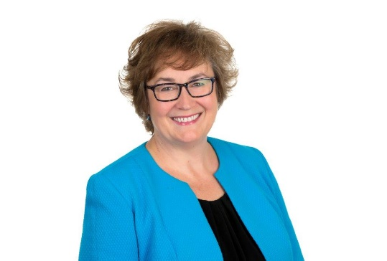
Speaker Bio
Kim Freeburn, BComm, CPA, CA, CEC

“Kim is a passionate developer of strong talent through advocacy and a coach-approach leadership style.”

Kim Freeburn is founder of Stratitude Corp. and the Regional Director for the CFO Centre, where superstar CFO’s help ambitious entrepreneurs achieve extraordinary things. She has more than 25 years of corporate experience helping business owners, large and small, resolve critical business issues and develop strategies to enhance shareholder value and overall financial results.

An experienced Finance Leader, Kim spent 22 years as a CFO for Sysco Corporation, a Fortune 100 company, working closely with Operations, Sales, HR, and Talent Management to build sustainable teams and practices while achieving superior financial results.

She has spent the last 6 years working with mid-size and owner-managed companies to build value for the long term by translating complex problems into clear, measurable, AND meaningful actions so entrepreneurs can have the time and money to do what they love.

Her collaborative approach ensures business decisions are wholistic and values based.

She has successfully led large and small teams through cash flow initiatives:
- Cash flow planning for start-ups and scale-ups
- Building cash flow in crisis
- Developing a long-term plan for sustainability and financial health
- Business strategy which integrates Operations, HR, IT and Finance support as core stakeholders.

Kim volunteers with the Innovation Cluster and Women’s Business Network of Peterborough. She holds a Bachelor of Commerce degree, is a Chartered Professional Accountant and a Certified Executive Coach.
Recent Speaking Engagements
Kim is a regular speaker, panelist, and presenter in her business community.
- Innovation Cluster (March 2021 – present)
  - Cash Flow Essentials for New Entrepreneurs
  - Start-up Visa: Hands-On Cash Flow
  - Women Breaking Barriers: Investor Readiness and Exist Strategies
  - Presentation Style

- Speaker Series (August – November 2021), sponsored by TD Bank
  - How to Build a Sustainable and Renewable Business Structure for Long Term Success: 4 Part Series exploring Mindset, Structure, Agility and Collaboration in owner-led businesses.
  - Panel Discussion

- Peterborough Chamber of Commerce (July 2021)
  - Numbers That Really Matter
  - Presentation style

- Webinar (August 2021)
  - 3 Keys to Unlocking Success in Your Business Through People, Finance & IT, Sponsored by MicroAge Peterborough/Whitby
  - Panel discussion

